**Unused Medicines and Other Things Donation System**

**Abstract:** This abstract discusses the importance of an unused medicine donation system and other things for non-governmental organizations (NGOs) and outlines the key steps involved in creating such a system. The system involves identifying potential donors, creating a clear and straightforward donation process, partnering with NGOs to distribute the donated medications to those in need, training staff and volunteers, and monitoring and evaluating the effectiveness of the system. This system ensures that unused and unexpired medications are put to good use and provides life-saving medications to vulnerable communities.

Medications are a fundamental component in lightening enduring, and gifts of clinical supplies with incredibly profit worldwide helpful aid projects. This medication gift application is about the assortment of medication that is unused by the patient who recuperates totally and remaining prescriptions becomes squander, those medications can be gathered and utilized further. This excess medication can be utilized by NGOs, Hospitals who are to be sure for those prescriptions. By the utilization of this entry, there will be less wastage of drugs. The aim and object of this project are to prepare an Online Portal for the collection of unused medicines and other essential things so that they can be given to the people who are in need.

Keywords: Online Portal, Collection, Unused Medicine, NGOs and Donation, poor people, Medication, Hospitals, people in need.

**CHAPTER 1**

1. **INTRODUCTION**

**OVERVIEW**:

India is developing at a fast pace and has made quick walks in many fields since its autonomy. But, according to many researches and National Family Health Survey (NFHS), it is clear that the admittance to medical care is still a rising issue in many slums and rural areas. Tough India is classified as a developing country, poverty is still a major challenge. The Per Capita GDP in India is still around $1900, by which it is clear that many people in India still lack expensive medical care and are deprived of healthcare facilities.

Due to the poverty and illiteracy, the people below poverty line cannot/do not want to pay for the expensive medical care because the cost of many medicines is so high that they prefer to buy food over medicines. Due to this issue, they suffer many diseases that turn into life-threatening issues if not taken care in time. Whereas, people whose per capita income is more and stable can afford these medical products and also preserve them for future need.

**OBJECTIVE**:

An unused medicine donation system for NGOs can be a valuable way to ensure that unused and unexpired medications are put to good use.

**MOTIVATION**:

Here are some key steps to creating such a system:

* *Identify potential donors*: Reach out to healthcare facilities, pharmacies, and individuals who may have unused medications. You can also consider partnering with medication manufacturers or distributors who may have surplus products.
* *Create a donation process*: Develop a clear and straightforward donation process, including guidelines for accepting donations, methods for packaging and labeling donations, and a system for tracking and storing donated medications.
* *Partner with NGOs*: Identify NGOs that work with vulnerable communities and have a need for medications. Work with these organizations to establish a process for distributing donated medications to those in need.
* *Train staff and volunteers*: Ensure that all staff and volunteers involved in the donation system are properly trained in the guidelines and protocols for accepting, tracking, and distributing medications.
* *Monitor and evaluate the system*: Regularly assess the effectiveness of the system, including the volume and quality of donations received, the timeliness and effectiveness of medication distribution, and any challenges or areas for improvement.

**GENERAL SURVEY:**

A survey is conducted for various applications related to our project and tested various systems that follow this same principle. A walkthrough was conducted of various guidelines related to Drug Donation and what policies and programs are followed throughout the world in this area. The Guidelines released by WHO to implement such Medicine Donation Programs was researched and found out about various new factors and precautions should be taken while this donation process takes place. The following is the gathered data that was collected by reading and shortlisting the references were followed. The various drug donation campaigns that take place in India was studied and a detailed analysis on the topic is prepared.

By implementing an unused medicine donation system for NGOs, you can help ensure that life-saving medications are not wasted and are instead provided to those who need them most. The remainder of this paper presents our research findings and implementation plan for this issue. Section II provides background information on previous related works and our review of them. Section III outlines the conceptual design, including architecture diagrams, DFDs, and other relevant structural details. The resulting evaluation is discussed in Section IV, followed by the conclusion in Section V.

**CHAPTER 2**

1. **LITERATURE SURVEY**

**2.1 Drug Repository Programs: Getting Medications to People Who Need Them; Published on April 19, 2022; Written by Joshua Murdock, PharmD, BCBBS | Reviewed by Alyssa Billingsley, PharmD.**

In this paper, it is discussed that valuable medicines are going to waste in many parts of the world when there is need by the people for it. To overcome this situation, a range of methods are introduced. The feeling of frustration is prevalent in the field of pharmacy due to drug waste. When medications are left unused, it can have a negative impact on various individuals and organizations, including hospitals, pharmacies, and medication users, resulting in financial losses and wasted resources. To address this issue, drug repository programs have emerged to minimize drug waste by redistributing safe and unexpired medications to those who require them. However, it's essential to understand what these programs entail and how they function.

This article aims to discuss drug repository programs in detail, including their definition, availability, and significance to the general public. Drug repository programs are designed to repurpose unused and unexpired medications to prevent drug waste and enhance medication access for eligible individuals. While these programs are gaining popularity and becoming more prevalent in specific states and regions across the United States, it's crucial to note that each program has its own set of regulations. Therefore, only a limited group of people can donate or receive medication through these programs, and only certain types of medications are eligible for redistribution.

The article also states that, a drug repository program refers to a pharmacy organization that collects and donates unused medications to individuals who require them, thereby controlling drug waste and enhancing medication access. While these programs are only available in specific regions, as of late 2021, active programs can be found in 28 states across the United States. If one wishes to receive medication from a drug repository program, they should contact the program directly as each program has its own set of eligibility requirements that must be met. By doing so, individuals can determine if they qualify for the program's services.

* 1. **JOURNAL OF EMERGING TECHNOLOGIES AND INNOVATIVE RESEARCH (JETIR); ISSN:2349 5162;** **2022 JETIR January 2022, Volume 9, Issue 1**

In this paper, it mainly focuses that “Health is a vital issue for the human race.”

In recent times, people’s concern regarding health issues has increased exponentially. For developing countries, health care is a fundamental need. Due to the scarcity of doctors and physicians, people of the developing countries have less access to healthcare services. Thus, healthcare is a very challenging in these countries. People living below the poverty line are NOT capable to buy many kinds of medicines when needed. The aim and objective of this medicine donator project is to develop build a website for the collection of unused medicine from Donor for further utilization by Needy persons. To provide flexibility to the users, the interfaces have been developed that are accessible through a browser.

The GUI’S at the top level have been categorized as Administrative user interface The operational or generic user interface. A donation of tablets, when well organized and controlled, can save lives and ease the pain. Actual donation practices can provide savings in forecast for development funding, so that these facilities can bused for other purposes. The "Online Medicine Donation System" serves as a bridge between a huge network of medicine donations and NGO'S. Old Age house.

The passage discusses different types of user interfaces in an online medicine donation system, including the management user interface, operational or generic user interface, and directing user interface. The directing user interface focuses on organizational activities that require proper confirmation for data collection, while the operational or generic user interface assists end users in transactions through existing data and required services.

The passage also discusses input design, which is an important part of system design. The main objective during input design is to produce a cost-efficient method of input that achieves the highest possible level of validity and is understandable to the user. The passage notes that choice must be made about input media, considering factors such as type of input, flexibility of format, speed, accuracy, verification method, rejection rates, ease of correction, storage and handling requirements, security, ease of use, and portability.

Based on this description, it is suggested that most of the inputs in the online medicine donation system are of the form of internal and interactive, and that the keyboard is the most suitable input device for inputting data directly.

* 1. **REIMAGINING ACCESS FOR THOSE IN NEED; SIRUM (Supporting Initiatives to Redistribute Unused Medicine); by Stanford University in 2009.**

This paper focuses on; “SIRUM” (Supporting Initiatives to Redistribute Unused Medicine) is a non-profit social enterprise started by Stanford University students to decrease the amount of medicine going to waste in the U.S. by redistributing unused, unexpired drugs to safety-net clinics. Using an innovative technology platform, SIRUM saves lives, time, and money by allowing health facilities, manufacturers, wholesalers, and pharmacies to easily donate unused medicine rather than destroy it.

SIRUM is a technology-based platform that addresses the problem of unused medicine and connects it with those in need. The platform provides an innovative solution by allowing donor organizations to upload inventories of their unused medications and safety-net clinics to upload their patients’ medication needs. The platform then uses its automatic matching system to find the best matches between the donor and recipient parties, facilitating the direct shipment of medicine from facility to clinic. SIRUM’s platform manages the logistics of the process, including record-keeping and shipping. The goal of SIRUM is to make medicine donation an easier and more appealing option than medicine destruction. This innovative approach can help to reduce waste, save costs, and improve access to medication for those who need it the most.

Their main motive is about: “Stop medication waste. Save lives.”

With millions of people unable to afford their prescriptions each year, how can we let perfectly good medicine go unused? Up to $11 billion in unopened, unexpired medicine gets destroyed each year. With help, we can turn that waste into life-saving care for people who need it.

*Achievements:* As of mid-2014, SIRUM has medicine redistribution networks running in California and Colorado, with over 200 partners participating in total. The organization has facilitated the redistribution of 1 million pills, which amounts to about $3 million worth of drugs saved and 20,000 patients helped. That also represents about two tons of medicine diverted away from our waste streams—and thousands of tons more waste avoided by forgoing the production of the 1 million pills these safety-net clinics would have otherwise had to purchase anew.

* 1. **MEDICINE DONATION SYSTEM: AN EFFECTIVE DISTRIBUTED TOOL DURING COVID-19 PANDEMIC; by Suresh Palarimath on August 21, 2021.**

This paper focusing on the difficulties faced during the COVID-19 PANDEMIC with distribution of medications and the wastage it led to.

The proposed online medical donation system based on the Software-as-a-service (SaaS) approach can be a helpful solution for managing medical donations in a faster and distributed way. The system has two phases of development, the local phase and the distributed phase. The system aims to facilitate the donation of unused medicines to needy individuals or NGOs. Donors can register on the system and upload details of the medicines they want to donate. They can also choose the counter where they would like to donate the medicines. Needy individuals or NGOs can register on the system as receivers and collect the donated medicines from the nominated counters. The system also allows donors to check their previously donated medicine details by logging in.

This system can be a useful tool, especially during the COVID-19 pandemic when many people are facing financial difficulties in affording medical treatments. By donating unused medicines, donors can help people in need and contribute to the healthcare system. The system can also help in managing medical donations in a more organized and efficient way, reducing wastage and ensuring that the medicines reach the intended recipients. The detailed research phases and related literature studies reported in the paper can provide valuable insights for developing and implementing such a system.

**CHAPTER 3**

3.1 EXISTING SYSTEMS

The previous systems required donors to manually check the expiry date of donated medicines and to avoid donating those that were close to expiring. Our proposed system, on the other hand, automatically checks the expiry dates of donated medicines, streamlines the donation process by assigning collection centers, and can be accessed from any device without requiring a separate application download. In contrast to existing medicine donation apps, our proposed system offers additional features such as user validity checks, inventory management, donor-to-receiver flow, doctor consultation modules, drug information and education forums, and other tools to simplify the donation process.

Prior systems only included basic functionalities such as login, donation, and collection, and lacked the guidance modules that are necessary to familiarize users with the application. Our proposed system addresses these issues and provides a comprehensive solution that repairs all the errors and shortcomings of previous systems.

Existing systems are based on outdated guidelines from WHO and are not standardized or affiliated with NGOs, which can cause internal conflicts and false expectations. In our proposed system, we have partnered with a specific NGO to manage all received donations, which prevents such issues and ensures streamlined operations.

* 1. PROPOSED SYSTEM

The proposed project aims to create a website where users can donate their unused medicines to an affiliated NGO, which can then distribute them to those in need. By submitting images of the medicines they wish to donate, users can help ensure the condition of the medications and prevent confusion on the NGO's side. A new AI Image Search feature will be added to compare the donated medicine's condition to that of a new packaged medicine, a revolutionary addition to the portal. Currently, users and NGOs can register and log in, and medicine donations along with other items are moderated by the admin. In the future, the system may expand to include video consultation with doctors and prescription upload features. The proposed system's modules will include donations tracking, doctor consultation, drug information and education, guidance on proper donation methods, inventory management, medicine sorting, user validation, forums, and emergency notifications, among others, which were lacking in previous systems. The system aims to use information and communication technologies to enhance NGO activities and provide a more effective platform for common activities.

* 1. FUNCTIONAL REQUIREMENTS

A functional requirement is a statement of how a system must behave. It defines what the system should do in order to meet the user’s needs or expectations. Functional requirements can be thought of as features that the user detects. They are different from non-functional requirements, which define how the system should work internally (e.g., performance, security, etc.).

* The system should provide registration and login functionality for users, allowing new users to register and existing users to log in.
* The system should allow the donor to input the name, quantity, and contents of the medicines or things they wish to donate.
* The system should request images of the donated medicines or products to be uploaded by the donor.
* The system should provide real-time status updates of the donated medicines and other items to the donor.
* The system should send a notification to the donor when a representative from the NGO is on their way to collect the donated medicines.
* The system should store all collected medicine data in a database, sorting the data by prescription for different diseases.
* The system should include a module for educating users on proper medicine donation methods and providing information on various drugs.
* The system should send emergency notifications to all users when there is a need for specific medicines.
* The system should include a forum page for users to discuss their queries and receive guidance from experts and experienced users.
* The system should verify the identity of users by asking for valid documents such as Aadhar Card, Email or Phone Number.
  1. NON-FUNCTIONAL REQUIREMENTS

If you think of functional requirements as those that define what a system is supposed to do, non-functional requirements (NFRs) define constraints which affect how the system should do it.

* The system should have a user-friendly interface that is easy to navigate.
* The system should load the webpage within 4 seconds of the user's request.
* The system should comply with Web Content Accessibility Guidelines.
* All contents and components of the portal should be displayed correctly and in their specified locations.
* The database security should comply with the requirements of the Health Insurance Portability and Accountability Act (HIPAA).
* The software should be able to handle the specified loads and meet the performance requirements specified in the specifications.
* The system should be portable and compatible with the specified systems.
* The software should be easy to maintain, available for the maximum amount of time, and reliable.
* The software should be easy to use and learn.
* The system should comply with the latest security standards and be protected against external malware and attacks.

1. DESIGN AND DEVELOPMENT

The proposed system for unused medicines donation to NGOs will have the following design and development:

Front-end: The front-end of the system will be developed using HTML, CSS, and JavaScript. The user interface will be designed to be user-friendly and easy to navigate. The GUI will be designed to load within 4 seconds from request and meet Web Content Accessibility Guidelines.

Back-end: The back-end of the system will be developed using PHP and MySQL. The system will be able to handle specified loads and perform as per the specifications. The software will be easily maintainable, available for maximum time, and must be reliable.

User Authentication: The system will include a user authentication module that will ask the user for verified documents like Aadhar Card, E-mail, or valid Phone Number. The system will validate the user's credentials before allowing them to donate medicine.

Medicine Donation: The system will accept the name, quantity, and contents of the medicines that the user wants to donate. The system will also request images of the medicines that the donor wants to donate. An AI Image Search feature will search for the medicine on the Internet and provide the condition of the medicine that is to be donated. This feature will help to determine the condition of the medicine and prove beneficial for the segregation of the medicines at NGO and Collection Center Level.

Donation Tracking: The system will track the status of the donated medicine and display it to the donor for their satisfaction. The system will send proper notification to the donator when the representative from the NGO will arrive to collect the medicine. The system will store all the data of the collected medicines in a database and sort the data according to the prescriptions for different diseases.

Guidance and Education Module: The system will include a Guidance and Education module for the users to educate about proper methods to donate the medicines and information on various drugs. The module will provide guidance on medicines and proper donation methods education to the users.

Forums Page: The system will include a Forums Page for users to discuss their queries and so experts and other experienced users can guide them.

Emergency Notifications: The system will send notifications to all the users in case of emergency medicine requirements.

Security: The system will follow all the latest security standards and must not be vulnerable to external malware and attacks. The database security must meet Health Insurance Portability and Accountability Act (HIPPA) requirements.

Stakeholders:

**Admin** – An admin must be able to access the database and other information easily and be able to manage them. Facilities of updating, inserting and deleting must also be possible.

**User** – The user must be able to enter details that are necessary to access the system with ease. The user must have no issues and difficulties with the loading of pages or page breakdowns.

**NGO** – NGOs must be able to access the database and keep record of who they are donating to and what it is that is being donated. They must be able to know how much is required and how much is being donated.

Future Scope: The system can be expanded to provide treatment to the user via video consultancy with doctors providing prescription upload feature. It can be very beneficial to the user because as per the current situation of COVID-19, it is very important to follow government rules and regulations.

Overall, the design and development of the proposed system for unused medicines donation to NGOs will be user-friendly, secure, and reliable. It will provide a platform for users to donate unused medicines and help needy people who cannot afford their own medicines.

3.1 SYSTEM CONTEXT/LEVEL DIAGRAM

The block diagram presented in Figure 1 outlines the various external entities involved in the unused medicine donation system, including the Admin, Member Users (Donors and Receivers), Collection Centers, and Doctors. Each entity has a specific set of tasks and functionalities, which are described in detail.

The Admin is responsible for managing all users, approving appointments from receivers, and maintaining the database of total medicine distribution. The Donor can log in and donate medicines, view other users' donations, and check the status of their own donated medicines. The Receiver can register, log in, add prescriptions, and receive medications. The Collection Center can log in, accept medicines from donors, collect and segregate medicines, and update the database. Lastly, the Doctors can view patient prescriptions, consult patients, and specify appropriate treatment.

The data flow between these entities is also depicted in the diagram, providing a clear overview of how information is shared and processed throughout the system. Overall, this design ensures efficient management of donated medicines and effective delivery to those in need.

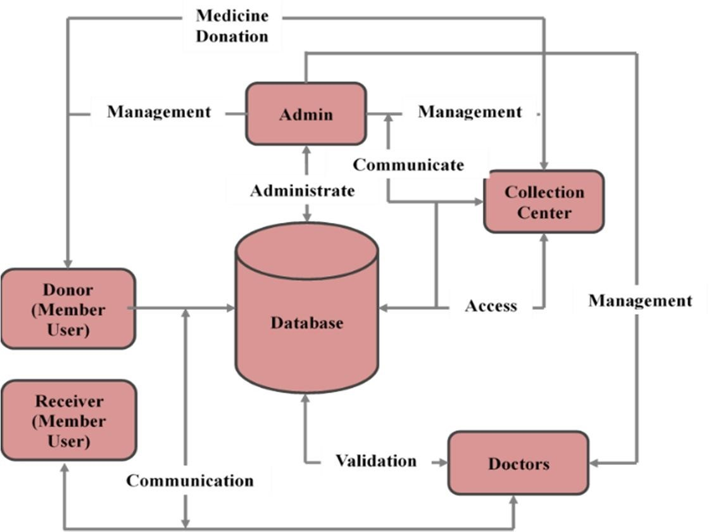

Figure 1: Block/Structural Diagram

* 1. COMPONENT DIAGRAM

The system will also have a database where all the donated medicines and prescriptions will be stored and sorted according to different diseases. This database will be updated by the collection centers which will accept the donated medicines and segregate them accordingly. The system will also send notifications to the donor when the representative from the NGO will arrive to collect the donated medicines.

Furthermore, the system will also include a guidance and education module for users to educate them about proper methods to donate medicines and provide information on various drugs. Additionally, there will be a forum page for users to discuss their queries and receive guidance from experts and experienced users.

To ensure the security of the system, the software will follow all the latest security standards and must not be vulnerable to external malware and attacks. The system will also meet the Health Insurance Portability and Accountability Act (HIPAA) requirements for database security.

Finally, the system will be user-friendly and easily maintainable. It will also meet web content accessibility guidelines and be compatible with specified systems. The software will be designed to handle the specified loads and must perform as per the specified requirements.

* 1. MODULE DESIGN AND ANALYSIS

1. *Admin Management Module*: This module allows the admin to manage the entire system. Admin has access to all functionalities and can approve or reject volunteer requests. Admin can also add, delete or modify user information and manage the database of donated medicines.
2. *Volunteer Management Module*: This module allows volunteers to register and request for approval from the admin. Once approved, volunteers can log in to the system and view the available medicines. They can also select medicines and assign them to respective NGOs.
3. *Medicine Management Module*: This module allows the admin to manage the database of donated medicines. Admin can view, add, modify or delete the details of medicines donated by the users.
4. *NGO Management Module*: This module allows NGOs to register and request for approval from the admin. Once approved, NGOs can log in to the system and view the medicines assigned to them by the volunteers. They can also update the status of the received medicines.
5. *User Management Module*: This module allows the admin to manage user information. Admin can view, add, modify or delete the details of users who have registered on the system.
6. *Donation History Module*: This module allows users to view their donation history. Users can view the details of the medicines they have donated along with the date and time of donation.
7. *Notification Module*: This module allows the system to send notifications to users about the status of their donated medicines. Users will receive notifications when their donated medicines are accepted by NGOs and when the medicines are distributed to the needy.
8. *Reporting Module*: This module generates reports on the status of donated medicines, medicines assigned to NGOs, medicines distributed to the needy, etc. Admin can generate reports based on different criteria and export them in different formats.
9. *Feedback Module*: This module allows users to provide feedback on the system. Users can give feedback on the system's usability, functionality, and other aspects to help improve the system.
10. Admin

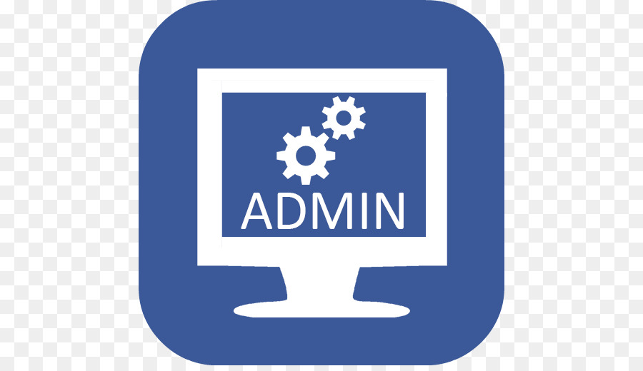 The Admin will have all the permissions with access controls of all the databases. He will also have full control over the users actions with the total control and administration of the Collection Centers. The NGO will go through all the requests from the receivers and will distribute the medications through the Collection Centers.

Functionalities of Admin

* + Login: Admin can login using credentials.
  + Manage Members: Admin analyses and deletes or blocks the member donating unwanted and drugs that pass their expiry dates.
  + Manage Approvals: The appointments by NGO’s are manage by approving appointment request. • Reporting: The monthly report of the members who had donated medicine.

1. Member Users (Donors and Receivers)

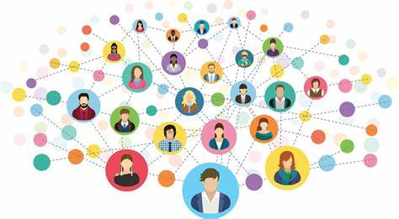 The Donors can login to the portal and donate the medications as per the user convenience. For the donation, the criteria are: The Medications must be a minimum of two months away from their expiration date; If syrups and other bottled products, they must not be leaking and also must be in a proper condition and quantity; The value of the medications to be donated must be above Rs. 200 and above. The Receivers can login and specify the prescriptions and required medications as per the doctor’s consultancy. The receivers must have a valid proof of their income with their ID (like Aadhar Card, etc.)

Functionalities of Member Users

* + Registration: User can register to the portal as either Donor or Receiver using the set credentials.
  + Login: User can login to the portal using the credentials.
  + Donate: Donors can select the ‘Donate’ option and follow the required procedure to give the medicines to the nearest Collection Center.
  + Search & Request: Receiver can search the required medications through the portal and request for it.

1. Collection Centers

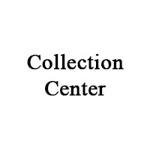The Collection Centers will manage and segregate the donated medications into separate categories and will update the status of the received donations into the portal.

Functionalities of Collection Centers

• Login: Collection Centers can login using their credentials.

• Receive: Collection Centers can receive the donated medications and segregate them into different categories.

• Update Status: Collection Centers can update the status of the received donations into the portal.

1. Doctors

The Doctors can prescribe the required medications for their patients who are unable to afford the costly medications.

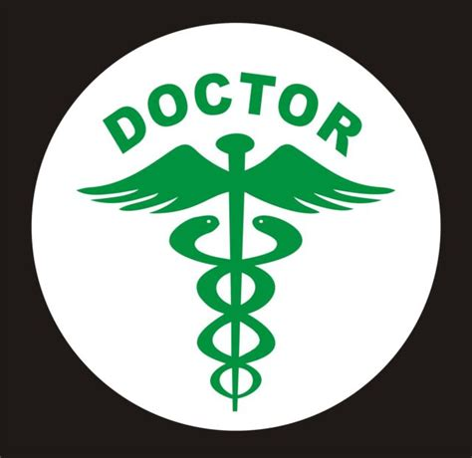

Functionalities of Doctors

• Login: Doctors can login using their credentials.

• View Patient Prescriptions: Doctors can view the prescriptions made by the Receivers.

• Consultation: Doctors can consult with the patients and provide them with the proper treatment.

The system is designed to be user-friendly, and easy to navigate for all types of users. It is hoped that this system will be able to bridge the gap between the donors and the receivers, thereby helping the needy and the poor get the medical assistance they require.

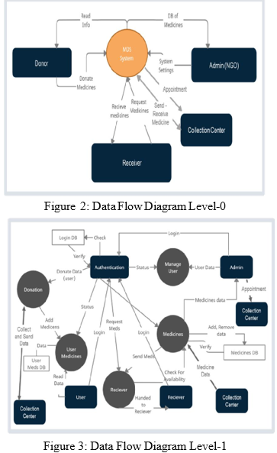

1. IMPLEMENTATION

That sounds like a great system to facilitate the donation of unused medicines to those in need. It's important to ensure that the donated medicines are verified and in good condition before they are distributed to the needy. The use of a portal to register donors and track their donations can help make the process more efficient and transparent. It's also great that the responsibility of managing and distributing the collected medicines will be with the NGO, which can ensure that they are distributed to those who need them the most. Overall, this system has the potential to make a positive impact on society and help provide healthcare to those who may not have access to it otherwise.

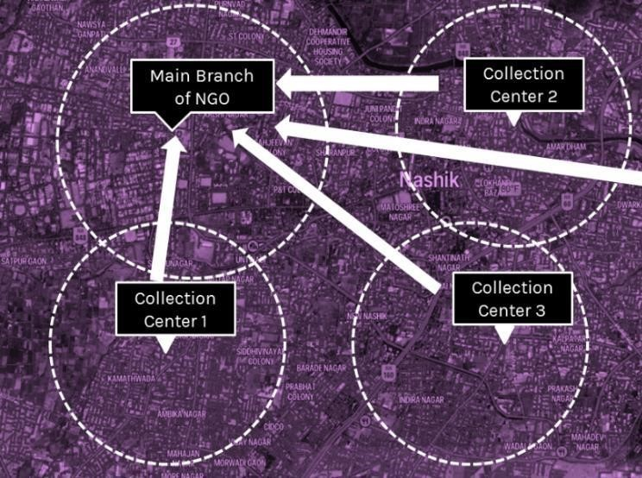

Figure 4: Implementation Demonstration

* 1. **CONCLUSION**

The proposed online medicine donation portal is a noble initiative that aims to provide healthcare services to the needy individuals who cannot afford expensive medications. The portal will not only help in providing free prescribed medicines to the poor but also reduce the wastage of unused and expired medicines.

In the future, the portal has the potential to become a full-fledged application that can provide a range of facilities such as video consultancy with doctors, blood donation, and more. The video consultancy feature can be particularly useful in the current COVID-19 situation, where physical consultation is not always possible.

Moreover, merging all the medication facilities under one platform can make it a unique and commercial portal, making it easier for individuals to access healthcare services. The proposed system is expected to contribute significantly to the society and help create a better world where everyone can receive the benefits of modern and expensive medication.

In conclusion, the proposed online medicine donation portal is a simple yet noble initiative that can help make a difference in the lives of the needy individuals. It is a call for each individual to contribute to society and help spread awareness about the plight of the poor and how such a simple act of donating leftover medicines can make a significant impact on their lives.

**REFERENCES**

[1]. https://www.ncbi.nlm.nih.gov/pmc/articles/PMC663114 1/

[2]. https://en.wikipedia.org/wiki/Systems_architecture#:~:text=A%20system%20architecture%20is%20the, and%20 behaviors%20of%20the%20system.

[3]. https://www.frontenders.in/blog/interesting-indian- healthcare-facts.html

[4]. https://www.arogyarakshayojana.org/

[5]. Dory J. Donation of medical device technologies. In: Dior J, ed. Clinical engineering handbook. Burlington, Elsevier Academic Press, 2004:155–158.

[6]. WHO Guidelines for Medicine Donations. 3rd ed. 2011. http://whqlibdoc.who.int/publications/2011 /9789241501 989 _eng.pdf. Accessed 2014 Dec.

[7]. Guidance on the application of the WHO Standard Assurance Scheme for Pharmaceutical Products Moving in International Trade. In: World Health Organization Expert Committee on Specifications for Pharmaceutical Preparations. Thirty - fourth report. Geneva, World Health Organization, 1996 WHO Technical Report Series Number 863.Annex10.

[8]. <https://www.jetir.org/papers/JETIR2201105.pdf>